Project Part 1
Total Marks - 60

Instructions:
- Plagiarism is a serious offense and will not be tolerated.
- Any student found to have copied code from any source will receive a grade of zero for the assignment.
- No work will be accepted after the due date.
- Submit ONLY .CPP file using the format RollNo.cpp i.e F2022-125.
ANY FILES VIOLATING THE SUBMISSION FORMAT WILL NOT BE CONSIDERED.

Objective of his Task:
The objective of this task 1 is to test the student’s understanding and mastery of object-oriented programming concepts such as abstraction, encapsulation, polymorphism, inheritance, association, aggregation, and composition which they have learnt throughout the semester. There are no restrictions in the assignment as what data type you have to use i.e vectors, strings or char arrays. However, you must make sure that there is no hardcoding in this assignment and it uses the concepts of OOP.

Description of the task:
In this task, you need to develop a banking management system that can help ABC Bank to manage their customers data efficiently. The system should be able to handle the requirements of the following stakeholders:
- User Client: An ordinary single user account which can only be opened by a person.
- Company Client: A multiple user account which can be opened by a Company’s CEO.
- Banking Employee: An Employee of the bank who will be able to manage the User and Company’s bank accounts.

Requirements:
There are 3 types of accounts that a customer can open in the bank. The information is provided in the table below for more details:

Account Type | Daily Withdrawal Limit | Account Restrictions
Bronze | 100,000 PKR | User Client/ Company Client
Gold | 500,000 PKR | User Client/ Company Client
Business | 20,000,000 PKR | Company Client

There are 3 types of transactions in your banking app:
  - Deposit
  - Withdraw
  - Transfer to another User Client
  - Refer to 4th (Other Requirements) Section for detailed explanation of these types.

User Client

A user client can open a new bank account by providing the following information:
  - Full Name
    - Address
    - Phone
    - CNIC
    - Login ID
    - Password
    - Estimated Daily Withdrawal Limit
You have to employee proper checks here in order to verify the information is not fraudulent. Once the banking employee approves the account, then assign the new customer a randomly generated 16 Digit Card Number and Prompt them to enter the PIN Number.
You also need to assign an appropriate account type according to the customer’s estimated daily withdrawal limit.
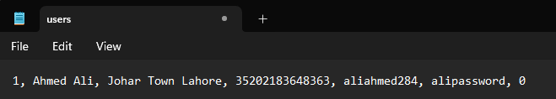
All of this information will be saved in a file “users.txt” in the following format:
The file format is saved as: userid, username, user address, user cnic, user id, user password, account
balance
  - The user client should be able to do the following:
    - They should be able to deposit and withdraw funds from their account.
    - They should be able to view their account balance and transaction history.
    - They should be able to transfer funds to other accounts within the bank.
  - Please note that you have to employee proper checks here i.e the user cannot withdraw amount greater than their balance or daily max limit is reached.
  - Account balance will be 0 for a new account

Company Client:
A company’s CEO can open a shared bank account on behalf of their company, whose access will be available to all of that company’s employees. It is assumed that all of the company’s employees already have an User Client account with the bank, i.e exist in the file “users.txt”.
  - Therefore, to open the Company Client’s Account, the CEO has to provide the following:
    - Company’s Name
    - Company’s Address
    - Company’s Tax Number
    - Estimated Daily Withdrawal Limit
    - Account’s ID
    - Account’s Password
Upon entering valid information for all of the above, you can save the information in a file named “companies.txt”. The format of the file is as follows:

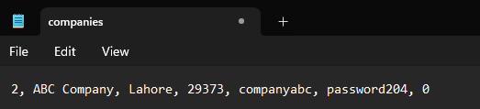
The file format is saved as: companyid, companyname, company address, company tax number, company user id, company password, account balance

  - The Company Client can do the following:
    - They should be able to deposit and withdraw funds from their account.
    - They should be able to view their account balance and transaction history.
    - They should be able to transfer funds to only user client’s accounts within the bank.
    - They should be able to request loans from bank.
Remember that multiple user’s can access this account via their Bank’s User ID as well if they are the part of the company. Therefore, you will have to maintain the data in another file named “companies_employees.txt” which will contain the following information:
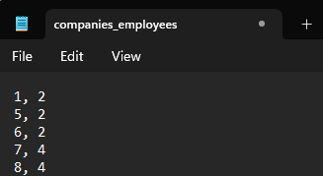
The file format is saved as: user client id, company id
      - This file depicts that User Client with ID Number 1,5,6 are employees of company with ID 2.
      - Similarly, User Client with ID 7 is employee of Company 4.
      - If the user client ID does not exist in this file, it means that user is not an employee of any company.
      - In order to give a choice to user, you can ask them which account would they like to access whether the company’s or their personal.

A User client & Company’s Client ID should be unique
- Banking Employee:
The banking employee can simply login to the system using their user id and password which is stored in the file named “admin.txt” and can do the following: Banking Employee:
- They should be able to view the list of all client’s accounts.
- They should be able to approve or reject new account applications.
- They should be able to approve or reject loan requests of companies.

- They should be able to view transaction history for a specific account.
- They should be able to freeze or close an account if necessary.

Other Requirements:
You also have to maintain a list of transactions of Client’s in a separate file named “transactions.txt”, then you can employ searching techniques on the files based on the user ID. The following is the format of the file:
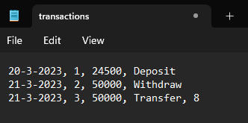
The file format is saved as: transaction date, Client User ID, Amount, Type of Transaction In case of transfer, the next will be the User ID to which the money was transferred to.
You also have to maintain the credit cards of Bank Client’s in a separate file and display them whenever information is required. The cards will be only assigned to the user once their new account is approved by the banking employee. The file is named as “cards.txt” and the format of file is as follows:
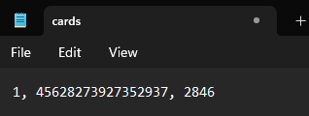
The file format is saved as: Client User ID, Card Number, Card PIN
Any transaction of User Client shall require their PIN Number of the Card that they are using. Note that a single user can have multiple cards. You can provide an option to the user while making the transaction for which card they want to use and then prompt them to enter the PIN Number. Upon entering the Pin successfully, the transaction should be made otherwise, it should give a message of decline. Upon 3 declines, it should mark the account as fraudulent and send a report to banking employee who can in turn mark the card as fraudulent and freeze the account.
You can use the class diagram below as a help to complete this assignment:

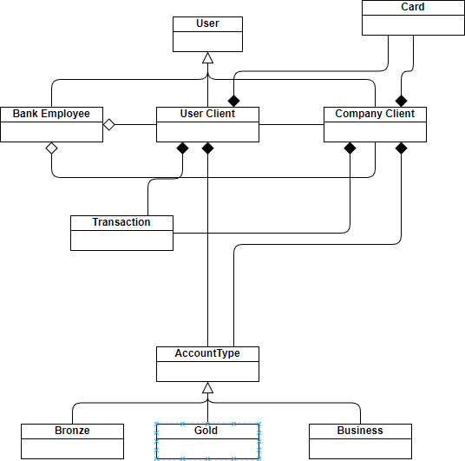

Following this class diagram is not mandatory, however it illustrates how you should use the concepts of aggregation, composition, inheritance and polymorphism in this question. Any hardcoding or brute force techniques will lead to deduction in marks. Your work will be evaluated upon the number of requirements completed and viva questions.
BEST OF LUCK

